FSR – Fisker Auto, recently went public via SPAC

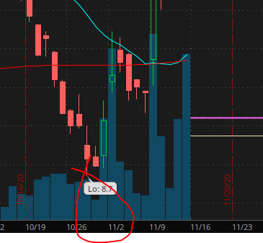

How to mathematically capture “this”, steady decrease in volume over 2-4 weeks with a significant drop in trading volume day or days prior to rapid/large institutional buys over the course of 1-2 weeks (Trading days)

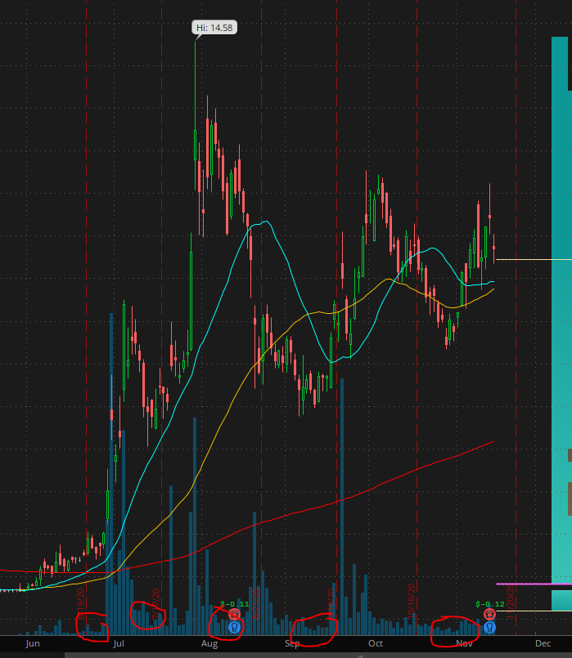BLNK – Same scenario as above however add in feature to notify when price is bottoming or repeating a similar trading pattern

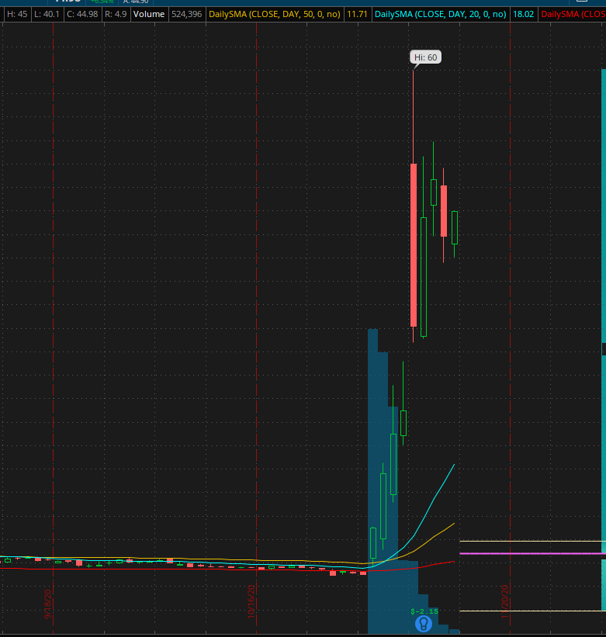APVO – Case where non-existent trading volume history then (20k shares to 30m shares) – biotech stocks have major catalysts that can cause these crazy swings. One good biotech trade can make you a millionaire (high alpha, high IV, high risk); hard to find misprices or biotech stocks that have positive catalysts where IV is < AV

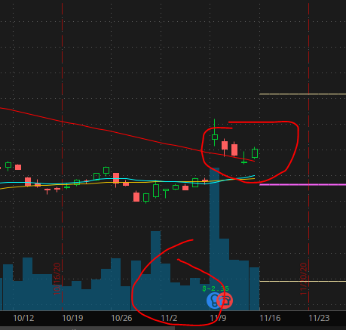NCLH – Same situation as above however added in technical case where daily SMAs were heading to a confluence, catalyst triggered; example of how options play on travel tickers would have yielded masstive alpha due to MMs pricing IV low but then AV was enormous thereby causing squeeze jacking option values through the roof

ROKU – Stay at home play, same case as above, garden variety, earnings was catalyst

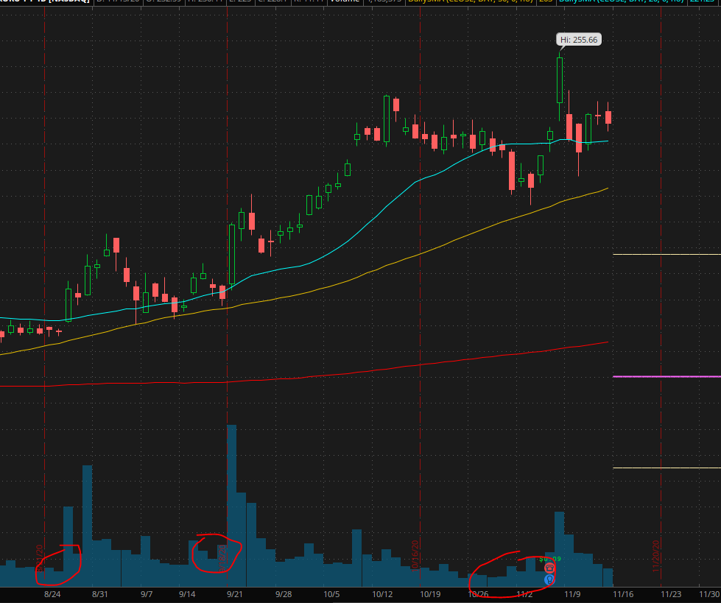

NIO –

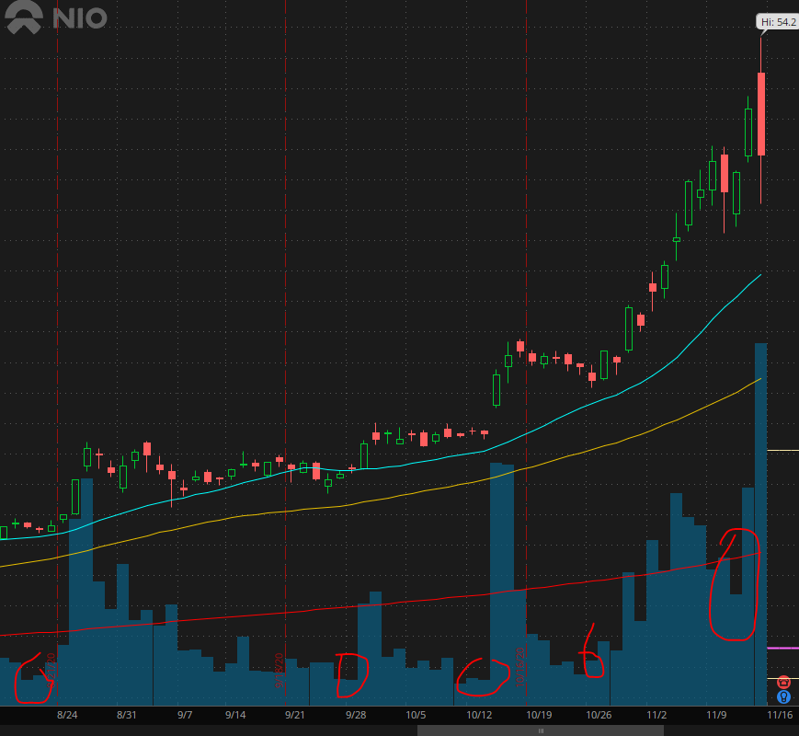

PLUG –

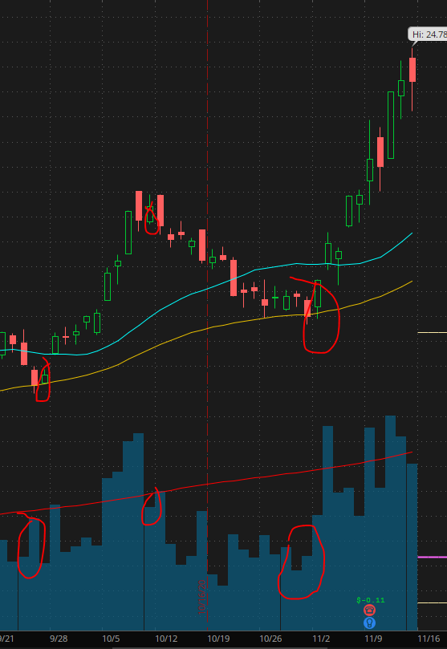

DIS –

